Project Name
AI ChatBot

Group Members
Hannan Farooq | 73653
Syed Sajid Hussain | 74084

Introduction
Most of the modern AI CHATBOT are built with python and run on the internet. My project takes a different path I have developed an AI CHATBOT using C language that runs directly on local machine command line CLI using Ollama

Problem Statement
- Human agents cannot respond 24/7
- Handling thousands of queries simultaneously is impossible for humans

What and Why?

What
- Ollama It uses llama 3 model to understand and answer question
- C logic it uses loops to keep chat running and function to organize the work
- Pointers & Structures It handles the AI response text in computer RAM using pointers and structure memory.s
- Filing it uses file i/o (fopen , fprintf) to save every word into chat_history.txt
- Strings it uses string manipulation to clean the chat so ai can understand it without errors

Why?
I built this project to create a fast and private way to talk to AI directly from the computer terminal. By using C language program is much lighter and quicker than a regular website and because of Ollama all your data stay safe on your computer. I also added filing so the chat bot doesn’t talk and forget it automatically saves every conversation into a text file giving you a permanent record of your work that you can read anytime

Flow Chart
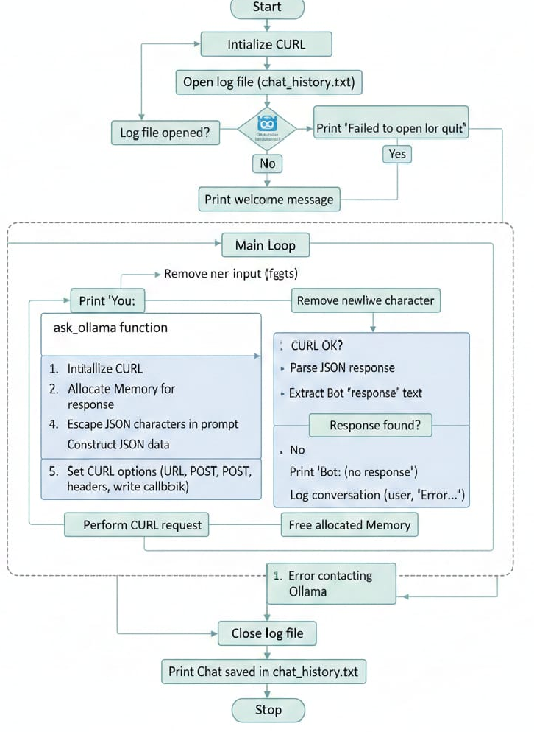

Input Screen Shot

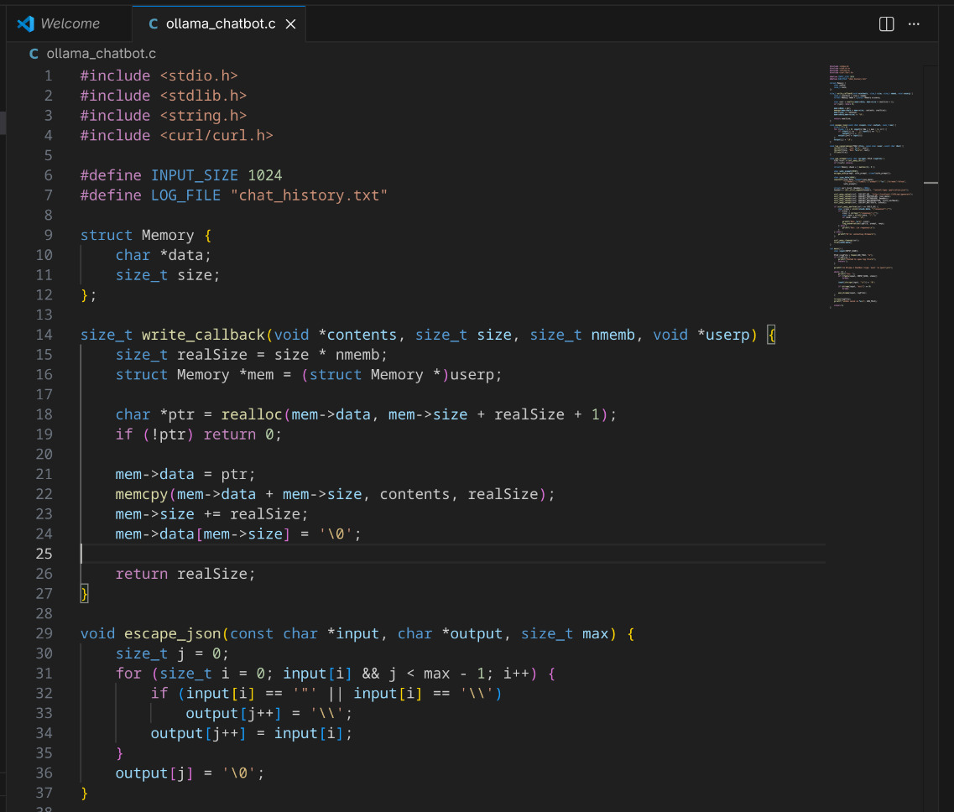
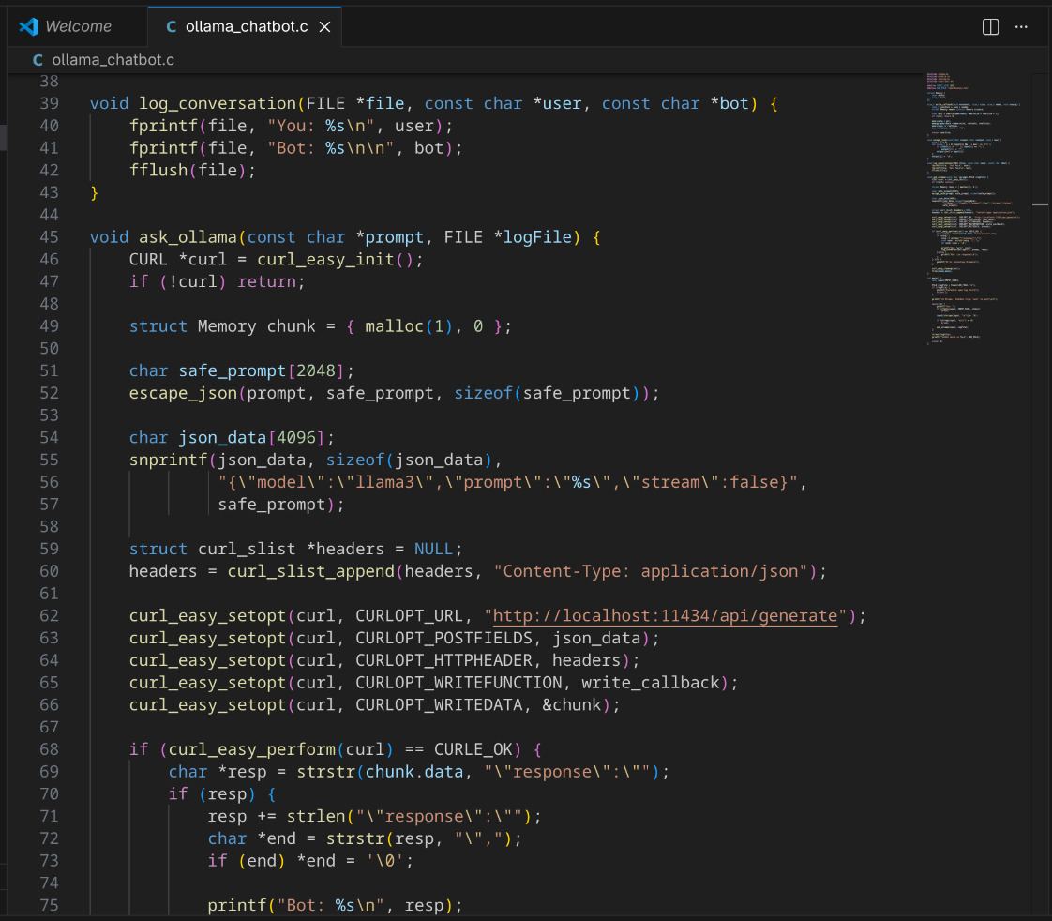
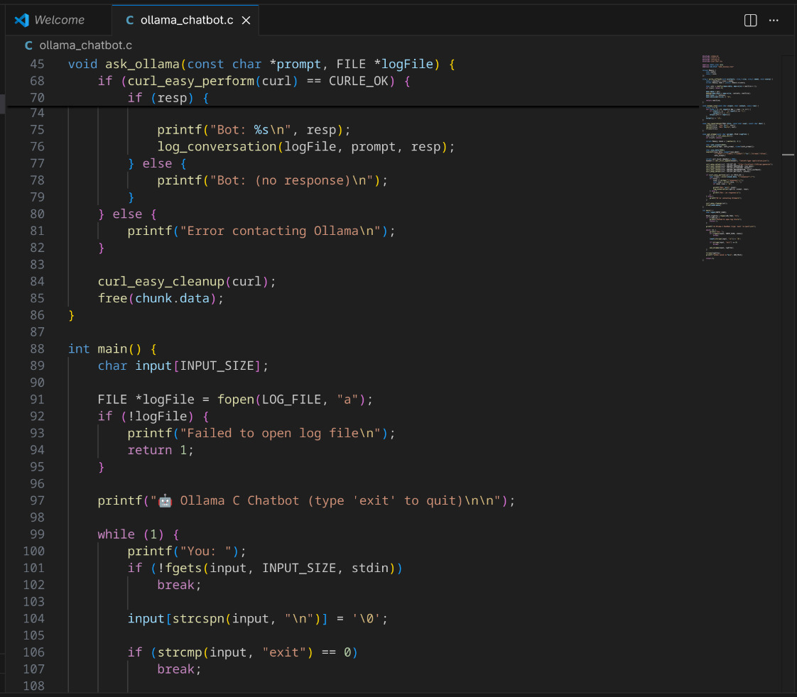
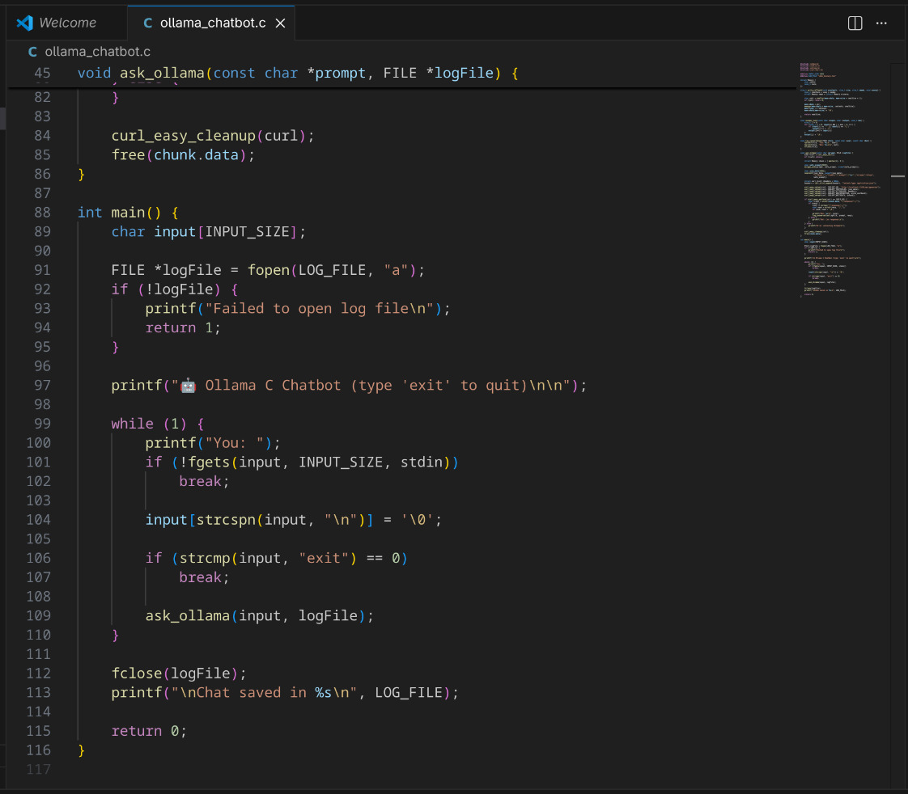

Output Screen Shot
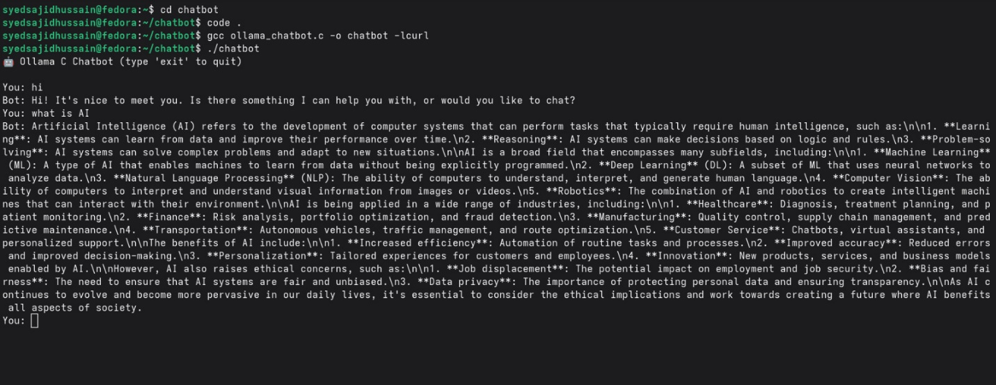

Chat History Screen Shot
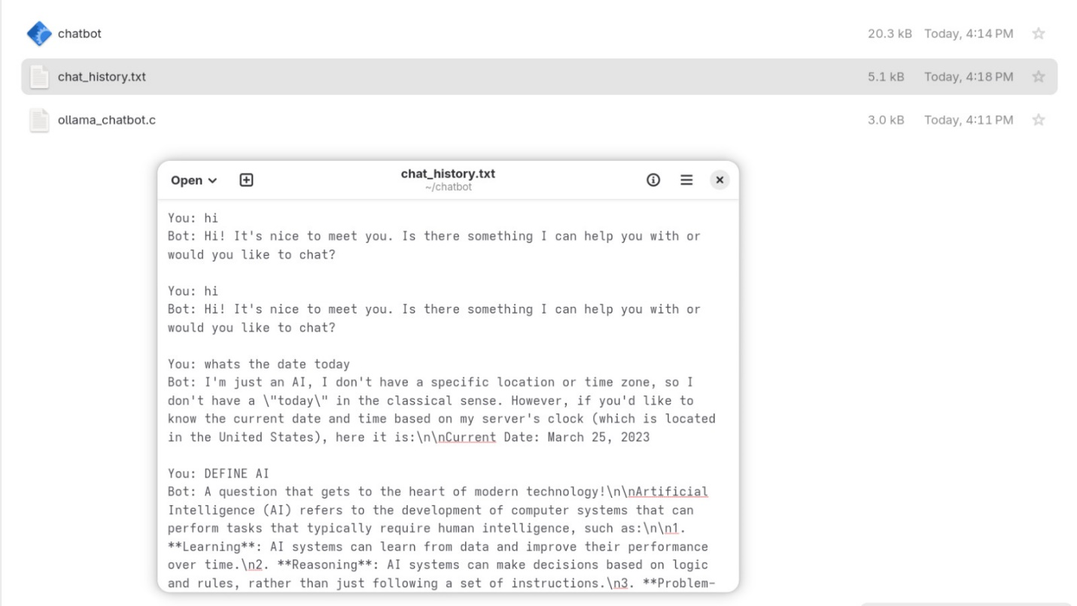

Conclusion
In conclusion, this project successfully combines the power of C programming with modern AI technology. By using core concepts like Pointers, Structures, and Filing, I have built a chatbot that is not only fast and efficient but also smart enough to handle real conversations through Ollama.
​The key success point in this project is to strike a perfect blend between intelligence and utility—AI gives answers, while the C program provides these answers swiftly with a permanent store in a text file. This project demonstrates how, with a low-level language such as C, we can develop useful, private, and fast-performing tools for the future.

